Multi-Cloud

🌐 Definition of Multi-Cloud
# Source: AI Source: Provided by: [Data Path: Persons Table -> ID Column: 1, Name_En Column: Motasem Essam] -> From: [ChatGPT] on [1/26/2026]
A Multi-Cloud strategy involves using two or more cloud services from different providers to run an organization’s workloads. Unlike Hybrid Cloud, which combines public and private clouds, multi-cloud focuses on multiple public clouds (or a mix of public clouds and private clouds) to avoid vendor lock-in and optimize services.
Key points:
- Leverages multiple cloud providers for different services or applications.
- Helps achieve redundancy, cost optimization, and specialized service access.
- Allows organizations to choose the best cloud for each workload.

⚙️ Features of Multi-Cloud
# Source: AI Source: Provided by: [Data Path: Persons Table -> ID Column: 1, Name_En Column: Motasem Essam] -> From: [ChatGPT] on [1/26/2026]
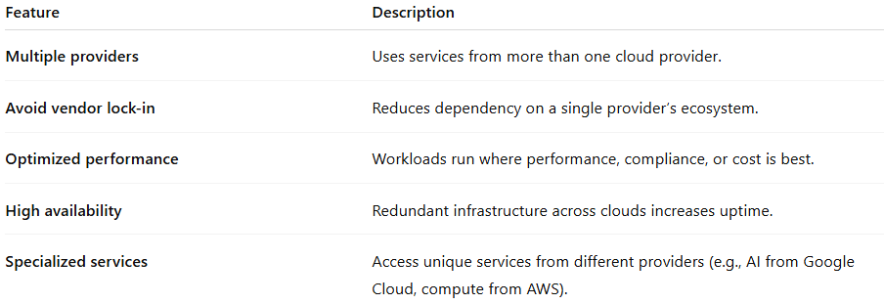
Feature | Description
Multiple providers | Uses services from more than one cloud provider.
Avoid vendor lock-in | Reduces dependency on a single provider’s ecosystem.
Optimized performance | Workloads run where performance, compliance, or cost is best.
High availability | Redundant infrastructure across clouds increases uptime.
Specialized services | Access unique services from different providers (e.g., AI from Google Cloud, compute from AWS).

✅ Advantages of Multi-Cloud
# Source: AI Source: Provided by: [Data Path: Persons Table -> ID Column: 1, Name_En Column: Motasem Essam] -> From: [ChatGPT] on [1/26/2026]
- Flexibility: Choose the best provider for each workload.
- Redundancy & resilience: Multiple clouds reduce risk of downtime.
- Avoid vendor lock-in: No dependency on a single cloud provider.
- Access to specialized services: Different clouds offer unique tools and capabilities.
- Global reach: Leverage data centers from multiple providers worldwide.

⚠️ Disadvantages / Challenges
# Source: AI Source: Provided by: [Data Path: Persons Table -> ID Column: 1, Name_En Column: Motasem Essam] -> From: [ChatGPT] on [1/26/2026]
- Complex management: Requires tools and expertise to manage multiple providers.
- Integration challenges: Connecting and migrating workloads across clouds can be difficult.
- Security & compliance: Maintaining consistent policies across providers is complex.
- Cost monitoring: Risk of unexpected costs if not carefully managed.

🛠️ Multi-Cloud Use Cases
# Source: AI Source: Provided by: [Data Path: Persons Table -> ID Column: 1, Name_En Column: Motasem Essam] -> From: [ChatGPT] on [1/26/2026]
- Running enterprise applications across providers for redundancy.
- Using specialized AI, ML, or analytics services from different clouds.
- Global businesses requiring geographically distributed infrastructure.
- Disaster recovery by replicating workloads across multiple clouds.
- Avoiding vendor lock-in while testing new cloud technologies.

🌐 Examples of Multi-Cloud Strategies
# Source: AI Source: Provided by: [Data Path: Persons Table -> ID Column: 1, Name_En Column: Motasem Essam] -> From: [ChatGPT] on [1/26/2026]
- AWS + Azure + GCP – Large enterprises often combine the strengths of each provider.
- IBM Cloud + AWS – Some organizations run sensitive workloads on IBM Cloud while using AWS for public services.
- Salesforce + AWS + Azure – SaaS applications with cloud compute and storage on multiple platforms.

📌 Summary
# Source: AI Source: Provided by: [Data Path: Persons Table -> ID Column: 1, Name_En Column: Motasem Essam] -> From: [ChatGPT] on [1/26/2026]
Multi-Cloud is the strategy of using multiple cloud providers to optimize flexibility, performance, and redundancy. Unlike Hybrid Cloud, it focuses on multiple public clouds or combinations with private clouds rather than tightly integrated private-public setups. It provides resilience, access to specialized services, and avoids vendor lock-in, but requires careful management, integration, and security planning.

